|  |  |  |
| --- | --- | --- |
| Door/key | 00(not pressed) | 01(pressed) |
| 00(locked) | 1 | 0 |
| 01(open) | 1 | 1 |

* Door locked, key not pressed: Alarm should activate (1).
* Door locked, key pressed: Alarm should deactivate (0).
* Door open, key not pressed: Alarm should activate (1).
* Door open, key pressed: Alarm should activate (1).

|  |  |  |  |
| --- | --- | --- | --- |
|  | Door | Key | Alarm |
| open | 0 | 0 | 0 |
| 0 | 1 | 0 |
| locked | 1 | 0 | 1 |
| 1 | 1 | 0 |

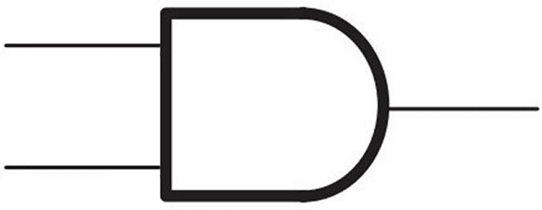

Y=D.K

K

D

|  |  |  |
| --- | --- | --- |
| DOOR  KEY | 0 | 1 |
| 0 | 0 | 1 |
| 1 | 1 | 0 |